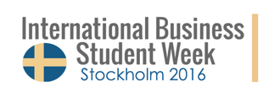
Application Form
Instructions on how to apply to International Business Student Week Date: May 9th - May 13th
- Fill out each and every one of the boxes below as thoroughly as possible.

- Save this Application Form by selecting “Save As” and rename the PDF in the following format:
IBSW-application_Lastname_Firstname_Country.

- E-mail the completed PDF before March 7th, 2016 to:
studentcoordinator.ibsweek@foreningenekonomerna.se
Note: put your name and country in the E-mail subject.

- Once you receive a reply from us that you are selected you need to confirm your application by forwarding your transport ticket (Flight, train, bus, ..) one week after you received the acceptance email to
studentcoordinator.ibsweek@foreningenekonomerna.se

Full Name
Address
Country
Phonenumber | (+...)
Email
Date of Birth
Language(s) and level | (native, fluent, intermediate, or beginner)
University
Program
Semester

Are you a member of a student association and if so, why? Please motivate.
What area of business are you most interested in? Please motivate.
Why do you want to participate in the Stockholm IBS WEEK 2016?
How did you find out about IBS Week?
Please note, your acceptance will not be valid until you have forwarded your travel reservations to us!

